**PSA: Evaluation of Three Polarizing Sars-Cov2 Treatments**

As of December 14th, 2021, a novel virus caused a cumulative 51,078,221 cases, resulting in 820,227 deaths and 40,194,733 recoveries. This virus is called Sars-Cov2, also known as COVID-19. What exactly is it? The virus consists of five key components. Starting from the outside in, we first find the protein covered with spikey proteins. These act as docking stations that allow the virus to bind to our cell receptors, ultimately leading to infection. These spikes anchor on a lipid layer embedded with structural proteins that act as an exoskeleton or skin. Inside, we can find a nucleocapsid protein, which is fancy talk for a protein that protects the viral payload. This payload consists of RNA, which essentially acts as a blueprint for building more viruses in the host cell (Boury, 2021). Finally, this RNA virus contains an enzyme known as RNA-Dependent RNA Polymerase. Since human cells use DNA to produce RNA, the virus needs its own "hardware" to replicate its RNA (Gao, 2020). See Figure 1 for a diagram.

How did COVID-19 become a pandemic? The One Health (OH) paradigm gives us a framework to analyze how pandemics arise. To summarize, we use the disease triangle, seen in Figure 2. It first starts with a virulent pathogen, which in our case, is the Sars-Cov2 virus. It is virulent because it is a virus that can be transmitted to and from humans. Second, it needs a favorable environment. Today's modern world with crowded cities and constant contact with hundreds of strangers daily provide a favorable environment. Finally, people are the susceptible hosts. These three elements were present in an open-air market in Wuhan, China, where this pandemic likely originated (Bhargava et al., 2021).

As serially mentioned in the MICRO 265x Packback Discussions and accompanying lectures, the politicization of COVID-19 led to an enterprise of mass misinformation, especially in the US. On the right, we see political pundits such as [Lowder with Crowder](https://www.louderwithcrowder.com/practicing-doctor-highlights-issues-of-leaky-vaccine-and-how-the-vaccinated-might-make-covid-19-worse) trying to downplay or even refute the COVID-19 vaccine. On the left, we see massive news networks like [CNN](https://www.cnn.com/2021/08/23/media/right-wing-media-ivermectin/index.html) misrepresenting drugs that could potentially help treat COVID-19 – even going so far as to say [that Joe Rogan took horse dewormer.](https://thehill.com/homenews/media/576723-gupta-tells-joe-rogan-cnn-shouldnt-have-called-ivermectin-horse-dewormer) With the massive number of cases in the US, it is necessary to know what drugs work. We will analyze the effectiveness of three highly polarizing drugs that gained media spotlight at some point: Ivermectin, Remdesivir, and HCO.

Let us start with Ivermectin. This drug has gotten international attention because several massive public health agencies have denounced it, with many such as the [NIH](https://www.covid19treatmentguidelines.nih.gov/therapies/antiviral-therapy/ivermectin/) citing a lack of robust evidence. Additionally, the President of the Association of American Physicians and Surgeons wrote a [fiery letter](https://aapsonline.org/aaps-letter-to-ama-re-ivermectin-and-covid/) to the American Medical Association challenging their denunciation of Ivermectin. CNN's misconception is understandable since this drug is the human equivalent of Equine Ivermectin, the veterinary version for treating parasitic infections. Ivermectin is approved for human use, with the researchers winning a Nobel Prize in Medicine for its development (Nobel Assembly, 2015). Since Ivermectin is originally an anti-parasite drug, it is still a shaky candidate for treating viral diseases. So, what does the evidence say about Ivermectin? Figure 3 shows an informative box and whisker plot summarizing the conclusions of all studies with treatment and control groups comparing Ivermectin's effect on COVID-19. Since these studies use different measures to assess drug efficacy, they are refactored as favored or not favored. It clearly shows that the overwhelming majority of research favors Ivermectin as a treatment option for COVID-19 and even as prevention. It is even more effective for early treatment. Another review in the American Journal of Therapeutics comes to a similar conclusion: Ivermectin has "moderate-certainty evidence" for reducing deaths (Bryant, 2021). Therefore, we can conclude that Ivermectin is likely an effective COVID-19 remedy.

Next, we can scrutinize Remdesivir. This drug gained international spotlight for being the first FDA-approved treatment for COVID-19 on October 22nd, 2020 (FDA, 2020). Additionally, the [National Institute of Health](https://www.covid19treatmentguidelines.nih.gov/therapies/antiviral-therapy/remdesivir/) (NIH) and many [other organizations](https://www.idsociety.org/practice-guideline/covid-19-guideline-treatment-and-management/) contradict the [World Health Organization's recommendations](https://www.who.int/news-room/feature-stories/detail/who-recommends-against-the-use-of-remdesivir-in-covid-19-patients) (WHO) for using Remdesivir. So, what does the evidence suggest? Figure 4 summarizes all research done on the antiviral's efficacy, including the massive studies done by the NIH and WHO. We find that most of the studies favor Remdesivir. There are no unfavorable studies with a confidence interval that includes zero improvement. The analysis also demonstrates varying effectiveness depending on which metric quantifies favorability (CovidAnalysis Remdesivir, 2021). Additionally, the mechanism of action for Remdesivir is well studied. It works by blocking or clogging the RNA polymerases needed for the virus to replicate its genome (Goldman, 2020). We can comfortably conclude that Remdesivir is an effective antiviral for COVID-19.

Finally, we can look at Hydroxychloroquine (HCQ), an antimalarial that was pasted on the front page of every major newspaper after being promoted by former US President Donald Trump. Highly respected news sources such as the [Washington Post](https://www.washingtonpost.com/politics/2021/06/21/hydroxycholoroquine-coronavirus-treatment-trump-allies-cant-quit/) and the [New York Times](https://www.nytimes.com/2020/04/25/us/coronavirus-trump-chloroquine-hydroxychloroquine.html) published several articles on the subject, each denouncing the efficacy of HCQ. So, what does the evidence suggest? Figure 5 contains box and whisker plots demonstrating that most studies on HCQs improvement in COVID-19 cases are favorable. It is even more effective for early treatment use. This database also highlights that 83% of randomized and controlled trials favor HCQ as a COVID-19 treatment with a 0.0038 probability of a type 1 error. (CovidAnalysis HCQ, 2021). While this is solid evidence, every major public health organization and government agency does not seem to be interested in endorsing it. Because of this, it is hard to recommend HCQ, but there is strong evidence that it could be an essential treatment.

It is important to remember that this pandemic is ever-evolving, just like the virus causing it. Data is never 100% reliable, and research is often misrepresented, poorly done, or non-conclusive. For example, many of the studies used in the meta-analysis of the drugs have relatively small sample sizes, making inference harder. With this in mind, we must take all evidence with a healthy dose of skepticism, including what this paper cites. Seek to disapprove, not approve our claims. If it still stands, you know the claim is valuable because it is more likely to be true.

The Sars-Cov2 pandemic taught us many lessons. The Spillover textbook also taught many of these lessons. For example, the media coverage for COVID-19 and the 1929 Parrot Fever are similar in that they do not have the expertise to properly aggregate and interpret what the scientific community produces (Lepore, 2009). Pandemics make great stories, but the facts often get neglected. Additionally, there will always be pushback from the fringe for any response to any disease. Just as Australian anti-vaxxers resisted the Hendra vaccine, we had conspiracy theorists and political pundits pushing against COVID-19 vaccines. They each used misinformation and petty complaints to justify their position. We can always combat this with adequate fact-checking, engaging in free expression in a marketplace of ideas, and relying on our scientific evidence. It is also important to remember that there is no single solution to our problems. We saw in our Packback discussions that people had different ways of approaching the Ribera problem in frogs. With COVID-19, we have the "Swiss cheese" approach. Perhaps multiple solutions, from vaccines to quarantine, are needed to deal with One Health pandemic issues. Keep calm and have an open mind.

**Works Cited**

Bhargava, H. D. (Ed.). (2021, August 15). *Coronavirus history: How did coronavirus start?* WebMD. Retrieved November 12, 2021, from <https://www.webmd.com/lung/coronavirus-history>.

Borrell, Brendan (2018, July 9th). *ANTI-VAXXERS ARE TARGETING A VACCINE FOR A VIRUS*

*DEADLIER THAN EBOLA.* The Atlantic. Retrieved December 14th, 2021, from <https://www.theatlantic.com/science/archive/2018/07/anti-vaxxers-horses-hendra/559967/>

Boury, N. (2021). *Basics of Covid 19.pptx*. Retrieved December 12th, 2021, from

<https://canvas.iastate.edu/courses/84765/pages/week-number-6-covid-19-organizing-page?module_item_id=4016649>

Bryant, Andrew (2021, July), *Ivermectin for Prevention and Treatment of COVID-19 Infection: A Systematic Review, Meta-analysis, and Trial Sequential Analysis to Inform Clinical Guidelines.* American Journal of Therapeutics. Retrieved December 14th, 2021, from <https://journals.lww.com/americantherapeutics/fulltext/2021/08000/ivermectin_for_prevention_and_treatment_of.7.aspx>

CovidAnalysis (2021, December 14). *HCQ for COVID-19: real-time meta analysis of 302 studies*. Retrieved on December 14th, 2021, from <https://hcqmeta.com/>

CovidAnalysis. (2021, December 11th). *Ivermectin for covid-19: Real-time Meta Analysis of 70 Studies*. Retrieved December 14th, 2021, from <https://ivmmeta.com/>.

CovidAnalysis (2021, December 14). *Outcomes in COVID-19 remdesivir studies.* Retrieved December 14th, 2021, from <https://c19rmd.com/meta.html>

FDA, (2020, October 22nd) *FDA Approves First Treatment for COVID-19*. Retrieved December 14th, 2021, from <https://www.fda.gov/news-events/press-announcements/fda-approves-first-treatment-covid-19>

Gao, Yan et al. (2020, May 15th), *Structure of the RNA-Dependent RNA Polymerase from COVID-19 Virus.* Science. Retrieved December 13th, 2021, from https://www.science.org/doi/10.1126/science.abb7498.

Goldman, Bruce (2020, June 29th), *How remdesivir works, and why it's not the ultimate coronavirus killer.* Stanford Medicine. Retrieved December 14th, 2021, from <https://scopeblog.stanford.edu/2020/06/29/how-remdesivir-works-and-why-its-not-the-ultimate-coronavirus-killer/>

Ledbetter, K. (2020, April 24th). *'Disease Triangle' indicates COVID-19 peak isn't the end*. AgriLife Today. Retrieved December 14th, 2021, from <https://agrilifetoday.tamu.edu/2020/04/21/disease-triangle-indicates-covid-19-peak-isnt-the-end/>.

Lepore, Jill (2009, May 31st). *In 1929, Parrot Fever Gripped The Country.* NPR. Retrieved

December 14th, 2021, from <https://www.npr.org/templates/story/story.php?storyId=104768337>

The Nobel Assembly at Karolinska Institutet. (2015, October 5th). *The Nobel Prize in Physiology or Medicine 2015 Press Release*. NobelPrize.org. Retrieved December 14th, 2021, from <https://www.nobelprize.org/prizes/medicine/2015/press-release/>.

**Figures**

Figure 1: Totally Accurate Covid Diagram (Boury, 2021)

Figure 2: Disease Triangle (Ledbetter, 2020)

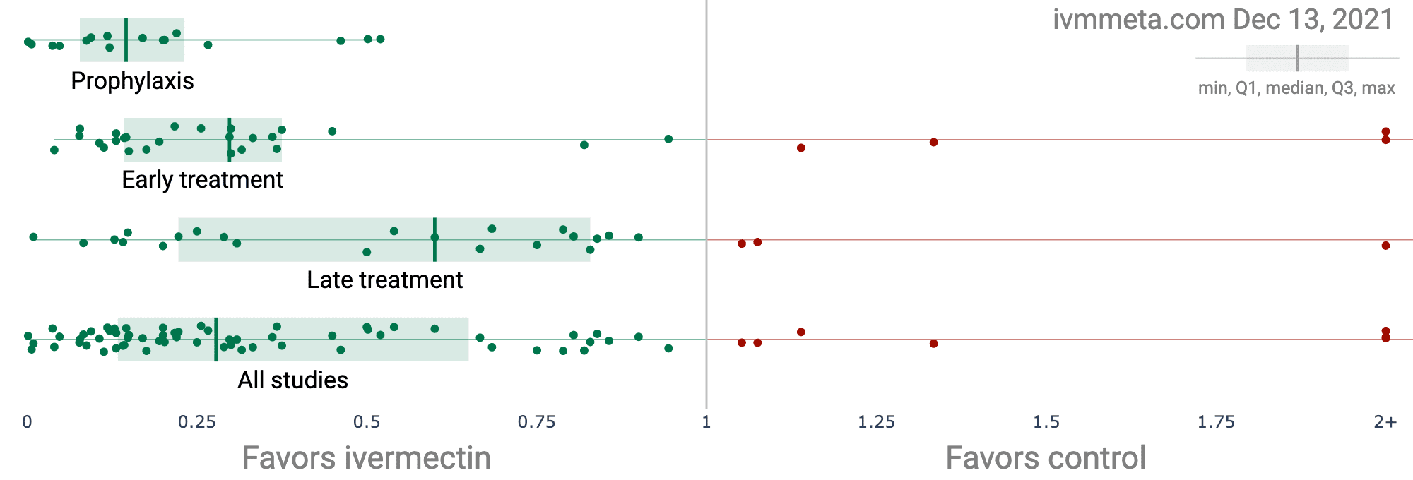

Figure 3: Ivermectin Studies (CovidAnalysis Ivermectin, 2021)

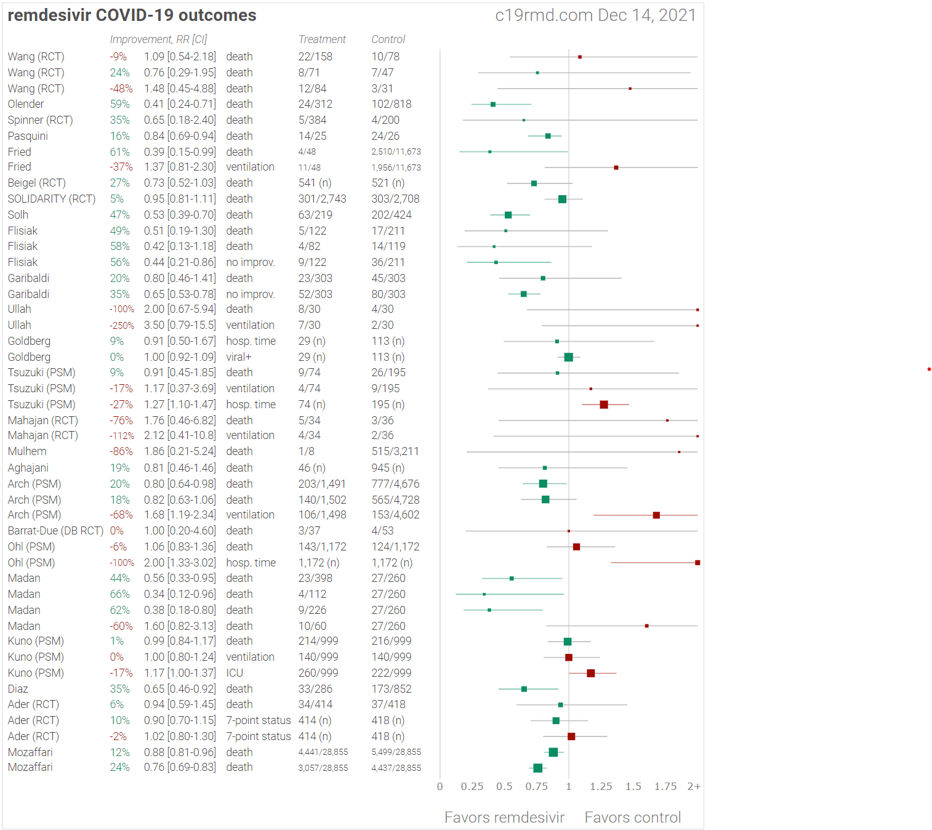

Figure 4: Remdesivir Research (CovidAnalysis Remdesivir, 2021)

Figure 5: HCQ Studies (CovidAnalysis HCQ, 2021)